Splicer Contais 2 Modules

1)Demuxer
2.)Muxer

Demuxer

Demuxer Recieves Video stream Over Ip and Number Each Packet and Stores Video Packets in Video pool ,Audio Packets in Audio pool and MetaData and PCR Packets in MetaSata Pool ,if It Got The Trigger It do the Same for Advertisement Video Stream

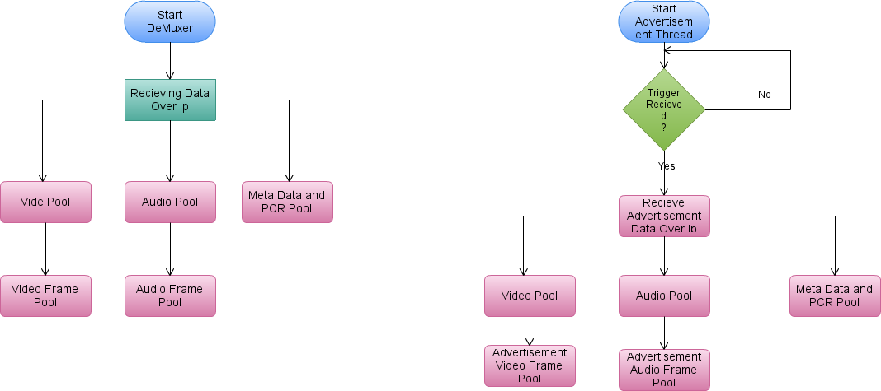

Muxer
This Module Mux all the Packets Back in to main Feed if the Frames Need to replace Then it Replaces Main Video/Audio Frames with Advertisement Frames and Then Transmits Content Over IP

